**LOOPS – For, for each, while, and do while!**

**For loop:**

for (loop variable initialization; testing condition; increment / decrement)

{

// statements to be executed

}

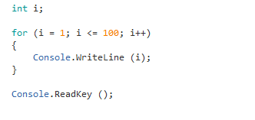

**For Each loop:**

int[] fibNumbers = new int[] {50, 20, 15, 5};

foreach (int element in fibNumbers)

{

count++;

Console.WriteLine($"Element #{count}: {element}");

}

**While loop:**

while (boolean condition)

{

loop statements...

}

while (x <= 4)

        {

            Console.WriteLine("GeeksforGeeks");

            // Increment the value of x for

            // next iteration

            x++;

        }

**You can do the same thing with a while loop as for loop. It’s just messier.**

Int i = 1;

while (i < 100)

{

   Console.WriteLine("i");

   i++;

}

**Do while:**

do

{

statements..

}while (condition);

 do

        {

            // The line will be printed even

            // if the condition is false

            Console.WriteLine("GeeksforGeeks");

            x++;

        }

        while (x < 20);

**Nested loop:**

 for(int i = 2; i < 3; i++) {

     for(int j = 1; j < i; j++){

         Console.WriteLine("GeeksforGeeks");

}

}